Scott Tabaka
Instructor: Galina Piatnitskaia
CS 3130 Spring 2019
Due Date: 4/30/2019
------------------------------------------------------------------------------------------------------Project#3 Part A

Binary Tree Created Binary Tree Height
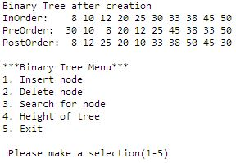
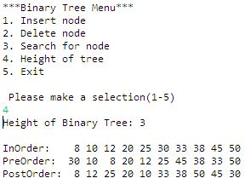
Binary Tree Search "38" Binary Tree Search "9"
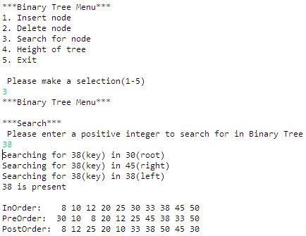
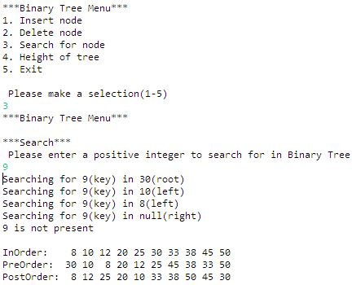
Binary Tree Delete "10"
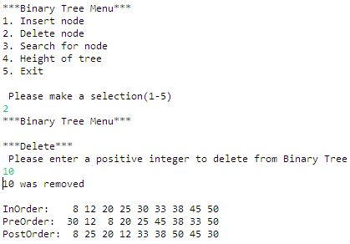

BinaryTree.java
package project3;

import java.util.Scanner;

/*
Author: Scott Tabaka
CMPSCI 3130 Project3

Purpose: A menu-driven program that creates a binary tree with data from project 3. It then has selections to insert/delete/search nodes as well as determining the height of the binary tree.
*/

public class BinaryTree
{
static Node root;
static boolean exit=false;
static boolean keyPresent=false;

class Node
{
int value;
Node left;
Node right;

Node(int value)
{
this.value = value;
right = null;
left = null;
}
}

public static void createBT(BinaryTree bt, int[] data)
{
for(int i=0;i<data.length;i++)
{
bt.insert(data[i]);
}

System.out.print("Binary Tree after creation");
display(root);
}

public static void createBT2(BinaryTree bt, int[] data)
{
for(int i=0;i<data.length;i++)
{
bt.insert(data[i]);
}
}

static int findHeight(Node current)
{
if(current == null)
{
return 0;
} else {
int left = findHeight(current.left);
int right = findHeight(current.right);
if(left > right)
{
return 1 + left;
} else {
return 1 + right;
}
}
}

static void height(Node current)
{
if(root == null)
{
System.out.println("No Binary Tree exists");
} else {
int height = findHeight(current)-1;
System.out.println("Height of Binary Tree: " + height);
}
}

static int treeheight(Node current)
{

return findHeight(current)-1;
}

private Node insertRecursive(Node current, int key)
{
if (current == null)
{
return new Node(key);
}
if (key < current.value)
{
current.left = insertRecursive(current.left, key);
} else if (key > current.value) {
current.right = insertRecursive(current.right, key);
} else {
return current;
}
return current;
}

public void insert(int key)
{
root = insertRecursive(root, key);
}

private static boolean containsNodeRecursive(Node current, int key)
{
if (current == null)
{
return false;
}
if (key == current.value)
{
return true;
}
if (key < current.value)
{
return containsNodeRecursive(current.left, key);
} else {
return containsNodeRecursive(current.right, key);
}
}

private static boolean searchRecursive(Node node, int key)
{
if (node == null)
{
return false;
}
if (key == node.value)
{
return true;
}
if (key < node.value)
{
if(node.left != null)
{
System.out.println("Searching for " + key + "(key) in " + node.left.value + "(left)");
} else {
System.out.println("Searching for " + key + "(key) in null(left)");
}
return searchRecursive(node.left, key);
} else {
if(node.right != null)
{
System.out.println("Searching for " + key + "(key) in " + node.right.value + "(right)");
} else {
System.out.println("Searching for " + key + "(key) in null(right)");
}
return searchRecursive(node.right, key);
}
}

public boolean search(int key)
{
System.out.println("Searching for " + key + "(key) in " + root.value + "(root)");
keyPresent=searchRecursive(root, key);
if(keyPresent)
{
System.out.println(key + " is present");
}else {
System.out.println(key + " is not present");
}
return keyPresent;
}

private int findMinimum(Node root)
{
return root.left == null ? root.value : findMinimum(root.left);
}

private Node deleteRecursive(Node current, int key)
{
if (current == null)
{
return null;
}
if (key == current.value)
{
if (current.left == null && current.right == null)
{
return null;
}
if (current.right == null)
{
return current.left;
}
if (current.left == null)
{
return current.right;
}
int minimum = findMinimum(current.right);
current.value = minimum;
current.right = deleteRecursive(current.right, minimum);
return current;
}
if (key < current.value)
{
current.left = deleteRecursive(current.left, key);
return current;
}
current.right = deleteRecursive(current.right, key);
return current;
}

public void delete(int value)
{
root = deleteRecursive(root, value);
}

public void deltree(int treenodes)
{
for (int i = 0; i < treenodes; i++)
{
delete(root.value);
}
}

public static void traverseInOrder(Node node)
{
if (node != null)
{
traverseInOrder(node.left);
System.out.printf("%2d ", node.value);
traverseInOrder(node.right);
}
}

public static void traversePreOrder(Node node)
{
if (node != null)
{
System.out.printf("%2d ", node.value);
traversePreOrder(node.left);
traversePreOrder(node.right);
}
}

public static void traversePostOrder(Node node)
{
if (node != null)
{
traversePostOrder(node.left);
traversePostOrder(node.right);
System.out.printf("%2d ", node.value);
}
}

public static void display(Node node)
{
System.out.printf("%-12s", "\nInOrder: ");
traverseInOrder(root);
System.out.printf("%-12s", "\nPreOrder: ");
traversePreOrder(root);
System.out.printf("%-12s", "\nPostOrder: ");
traversePostOrder(root);
System.out.println("\n");
}

public static boolean menu(BinaryTree bt, Scanner reader)
{
int n = 0;

while (!(n >= 1 && n <= 5))
{
System.out.println("***Binary Tree Menu***");
System.out.println("1. Insert node");
System.out.println("2. Delete node");
System.out.println("3. Search for node");
System.out.println("4. Height of tree");
System.out.println("5. Exit");
System.out.println("\n Please make a selection(1-5)");
n = reader.nextInt();
}

switch (n)
{
case 1:
n=0;
while(!(n >= 1))
{
System.out.println("***Binary Tree Menu***");
System.out.print("\n***Insert***");
System.out.println("\n Please enter a positive integer to insert into Binary Tree");
n = reader.nextInt();
}
keyPresent=containsNodeRecursive(root, n);
if(!keyPresent)
{
bt.insert(n);
} else {
System.out.println("That integer already exists");
}
break;
case 2:
n=0;
while(!(n >= 1))
{
System.out.println("***Binary Tree Menu***");
System.out.print("\n***Delete***");

System.out.println("\n Please enter a positive integer to delete from Binary Tree");
n = reader.nextInt();
}
keyPresent=containsNodeRecursive(root, n);
if(keyPresent)
{
bt.delete(n);
System.out.println(n + " was removed");
} else {
System.out.println("That integer does not exist");
}
break;
case 3:
n=0;
while(!(n >= 1))
{
System.out.println("***Binary Tree Menu***");
System.out.print("\n***Search***");

System.out.println("\n Please enter a positive integer to search for in Binary Tree");
n = reader.nextInt();
}

bt.search(n);
break;
case 4:
height(root);
break;
case 5:
exit = true;
System.out.print("\nExiting...");
break;
}

n=0;
return exit;
}

public static void main(String[] args)
{
BinaryTree bt = new BinaryTree();
Scanner reader = new Scanner(System.in);

int[] data = {30, 10, 45, 38, 20, 50, 25, 33, 8, 12};
createBT(bt, data);

while(exit==false)
{
exit = menu(bt, reader);
if (!exit)
{
display(root);
}
}

reader.close();
}
}

